Assignment 2 – Graphs (V1)

Please note that this is an individual assignment. Write your full name at the top in the space provided and record all your answers on this handout.

- Represent the relationships that exist between Node objects for each graph below for both styles. Use the space provided to record your answers.
  - adjacency list
  - adjacency matrix (you can omit placeholder values)

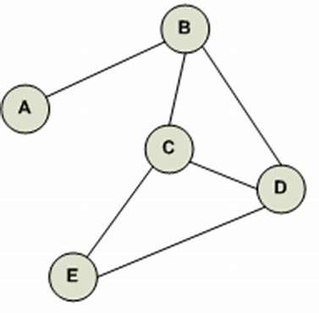
Undirected Graph

- [A] ________________________
- [B] ________________________
- [C] ________________________
- [D] ________________________
- [E] ________________________

 | A | B | C | D | E
A
B
C
D
E

Bonus, record the output for the following traversals:

Breadth-first Search: __________________________________

Depth-first Search: __________________________________

- Represent the relationships that exist between Node objects for each graph below for both styles. Use the space provided to record your answers.
  - adjacency list
  - adjacency matrix (you can omit placeholder values)
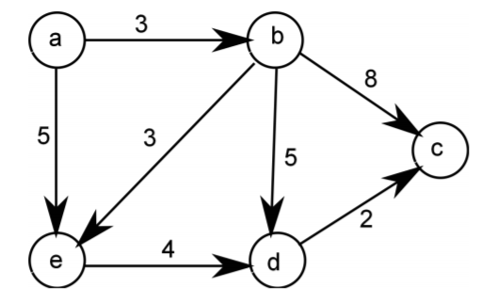
Directed Graph with Weights

- [a] ________________________
- [b] ________________________
- [c] ________________________
- [d] ________________________
- [e] ________________________

 | a | b | c | d | e
a
b
c
d
e

Evaluation:

Marks Available | Description
5  2.5  +1 | Undirected Graph  - Adjacency list representation  - Adjacency matrix representation  - Bonus  - Breadth-first traversal  - Depth-first traversal
5  2.5 | Directed Graph with Weights  - Adjacency list representation  - Adjacency matrix representation
15 | TOTAL
Assignment 2 – Graphs (V2)

Please note that this is an individual assignment. Write your full name at the top in the space provided and record all your answers on this handout.

- Represent the relationships that exist between Node objects for each graph below for both styles. Use the space provided to record your answers.
  - adjacency list
  - adjacency matrix (you can omit placeholder values)

Undirected Graph

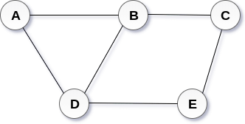
- [A] ________________________
- [B] ________________________
- [C] ________________________
- [D] ________________________
- [E] ________________________

 | A | B | C | D | E
A
B
C
D
E

Bonus, record the output for the following traversals:

Breadth-first Search: __________________________________

Depth-first Search: __________________________________

- Represent the relationships that exist between Node objects for each graph below for both styles. Use the space provided to record your answers.
  - adjacency list
  - adjacency matrix (you can omit placeholder values)

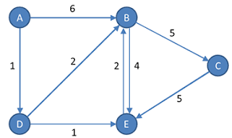
Directed Graph with Weights

- [A] ________________________
- [B] ________________________
- [C] ________________________
- [D] ________________________
- [E] ________________________

 | A | B | C | D | E
A
B
C
D
E

Evaluation:

Marks Available | Description
5  2.5  +1 | Undirected Graph  - Adjacency list representation  - Adjacency matrix representation  - Bonus  - Breadth-first traversal  - Depth-first traversal
5  2.5 | Directed Graph with Weights  - Adjacency list representation  - Adjacency matrix representation
15 | TOTAL
Assignment 2 – Graphs (V3)

Please note that this is an individual assignment. Write your full name at the top in the space provided and record all your answers on this handout.

- Represent the relationships that exist between Node objects for each graph below for both styles. Use the space provided to record your answers.
  - adjacency list
  - adjacency matrix (you can omit placeholder values)

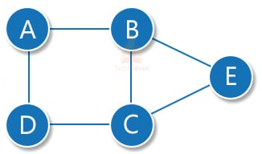
Undirected Graph

- [A] ________________________
- [B] ________________________
- [C] ________________________
- [D] ________________________
- [E] ________________________

 | A | B | C | D | E
A
B
C
D
E

Bonus, record the output for the following traversals:

Breadth-first Search: __________________________________

Depth-first Search: __________________________________

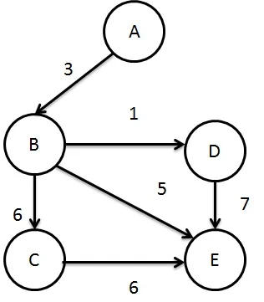
- Represent the relationships that exist between Node objects for each graph below for both styles. Use the space provided to record your answers.
  - adjacency list
  - adjacency matrix (you can omit placeholder values)

Directed Graph with Weights

- [A] ________________________
- [B] ________________________
- [C] ________________________
- [D] ________________________
- [E] ________________________

 | A | B | C | D | E
A
B
C
D
E

Evaluation:

Marks Available | Description
5  2.5  +1 | Undirected Graph  - Adjacency list representation  - Adjacency matrix representation  - Bonus  - Breadth-first traversal  - Depth-first traversal
5  2.5 | Directed Graph with Weights  - Adjacency list representation  - Adjacency matrix representation
15 | TOTAL
Assignment 2 – Graphs (V4)

Please note that this is an individual assignment. Write your full name at the top in the space provided and record all your answers on this handout.

- Represent the relationships that exist between Node objects for each graph below for both styles. Use the space provided to record your answers.
  - adjacency list
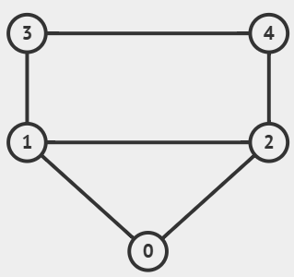
  - adjacency matrix (you can omit placeholder values)

Undirected Graph
5

- [1] ________________________
- [2] ________________________
- [3] ________________________
- [4] ________________________
- [5] ________________________

 | 1 | 2 | 3 | 4 | 5
1
2
3
4
5

Bonus, record the output for the following traversals:

Breadth-first Search: __________________________________

Depth-first Search: __________________________________

- Represent the relationships that exist between Node objects for each graph below for both styles. Use the space provided to record your answers.
  - adjacency list
  - adjacency matrix (you can omit placeholder values)
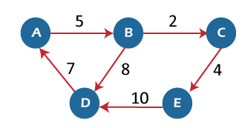
Directed Graph with Weights

- [A] ________________________
- [B] ________________________
- [C] ________________________
- [D] ________________________
- [E] ________________________

 | A | B | C | D | E
A
B
C
D
E

Evaluation:

Marks Available | Description
5  2.5  +1 | Undirected Graph  - Adjacency list representation  - Adjacency matrix representation  - Bonus  - Breadth-first traversal  - Depth-first traversal
5  2.5 | Directed Graph with Weights  - Adjacency list representation  - Adjacency matrix representation
15 | TOTAL
Assignment 2 – Graphs (V5)

Please note that this is an individual assignment. Write your full name at the top in the space provided and record all your answers on this handout.

- Represent the relationships that exist between Node objects for each graph below for both styles. Use the space provided to record your answers.
  - adjacency list
  - adjacency matrix (you can omit placeholder values)

Undirected Graph

- [A] ________________________
- [B] ________________________
- [C] ________________________
- [D] ________________________
- [E] ________________________

 | A | B | C | D | E
A
B
C
D
E

Bonus, record the output for the following traversals:

Breadth-first Search: __________________________________

Depth-first Search: __________________________________

- Represent the relationships that exist between Node objects for each graph below for both styles. Use the space provided to record your answers.
  - adjacency list
  - adjacency matrix (you can omit placeholder values)

Directed Graph with Weights

- [A] ________________________
- [B] ________________________
- [C] ________________________
- [D] ________________________
- [E] ________________________

 | A | B | C | D | E
A
B
C
D
E

Evaluation:

Marks Available | Description
5  2.5  +1 | Undirected Graph  - Adjacency list representation  - Adjacency matrix representation  - Bonus  - Breadth-first traversal  - Depth-first traversal
5  2.5 | Directed Graph with Weights  - Adjacency list representation  - Adjacency matrix representation

Assignment 2 – Graphs (V6)

Please note that this is an individual assignment. Write your full name at the top in the space provided and record all your answers on this handout.

- Represent the relationships that exist between Node objects for each graph below for both styles. Use the space provided to record your answers.
  - adjacency list
  - adjacency matrix (you can omit placeholder values)

Undirected Graph

- [A] ________________________
- [B] ________________________
- [C] ________________________
- [D] ________________________
- [E] ________________________

 | A | B | C | D | E
A
B
C
D
E

Bonus, record the output for the following traversals:

Breadth-first Search: __________________________________

Depth-first Search: __________________________________

- Represent the relationships that exist between Node objects for each graph below for both styles. Use the space provided to record your answers.
  - adjacency list
  - adjacency matrix (you can omit placeholder values)

Directed Graph with Weights

- [A] ________________________
- [B] ________________________
- [C] ________________________
- [D] ________________________
- [E] ________________________

 | A | B | C | D | E
A
B
C
D
E

Evaluation:

Marks Available | Description
5  2.5  +1 | Undirected Graph  - Adjacency list representation  - Adjacency matrix representation  - Bonus  - Breadth-first traversal  - Depth-first traversal
5  2.5 | Directed Graph with Weights  - Adjacency list representation  - Adjacency matrix representation

Assignment 2 – Graphs (V7)

Please note that this is an individual assignment. Write your full name at the top in the space provided and record all your answers on this handout.

- Represent the relationships that exist between Node objects for each graph below for both styles. Use the space provided to record your answers.
  - adjacency list
  - adjacency matrix (you can omit placeholder values)

Undirected Graph

- [A] ________________________
- [B] ________________________
- [C] ________________________
- [D] ________________________
- [E] ________________________

 | A | B | C | D | E
A
B
C
D
E

Bonus, record the output for the following traversals:

Breadth-first Search: __________________________________

Depth-first Search: __________________________________

- Represent the relationships that exist between Node objects for each graph below for both styles. Use the space provided to record your answers.
  - adjacency list
  - adjacency matrix (you can omit placeholder values)
Directed Graph with Weights

- [A] ________________________
- [B] ________________________
- [C] ________________________
- [D] ________________________
- [E] ________________________

 | A | B | C | D | E
A
B
C
D
E

Evaluation:

Marks Available | Description
5  2.5  +1 | Undirected Graph  - Adjacency list representation  - Adjacency matrix representation  - Bonus  - Breadth-first traversal  - Depth-first traversal
5  2.5 | Directed Graph with Weights  - Adjacency list representation  - Adjacency matrix representation

